SOCIAL, EMOTIONAL, MENTAL HEALTH (SEMH) POLICY

Document Control
This document has been approved for operation within: | All Trust Establishments
Date effective from | September 2021
Date of next review | September 2023
Review period | 2 year
Status | Mandatory - Trust
Owner | Education Partnership Trust
Version | 1

Contents
1.0 INTRODUCTION 4
2.0 AIMS 4
3.0 RESPONSIBILITIES 4
4.0 IDENTIFYING NEEDS AND WARNING SIGNS 6
5.0 STAFF/PARENTAL SUPPORT 7
6.0 LINKS 7
7.0 USEFUL WEBSITES 8
Appendix 1 – MHFA Flow Chart 9
Appendix2 – A graduated response to SEMH (*SEMH Strategy) 10
Appendix2 – Emotional and Mental Health Needs……………………………………………………………………11

1.0 INTRODUCTION
1.1 The School has a supportive ethos where each individual is valued reflecting the EPT’s values of High expectations, Commitment and Ambition.
1.2 All children and young people have the right to be educated in an environment that supports and promotes positive mental health for everybody.
1.3 All adults have the right to work in an environment that supports and promotes positive mental health for everybody.
1.4 The mental health of children and young people, adults in schools, parents and carers and the wider whole school community will impact on all areas of development, learning, achievement, and experience.
1.5 The school recognises that everyone experiences life challenges and aims to detect and address problems in the earliest stages to provide additional emotional support.
1.6 The Department for Education (DfE) recognises that “taking a coordinated and evidence-informed approach to mental health and wellbeing in schools and colleges leads to improved pupil and student emotional health and wellbeing which can help readiness to learn”.
1.7 The World Health Organisation’s definition of mental health and wellbeing “a state of wellbeing in which every individual realises his or her own potential, can cope with the normal stresses of life, can work productively and fruitfully, and is able to make a contribution to his or her own community.”

2.0 AIMS
2.1 To recognise our responsibilities in supporting students and staff with mental health and wellbeing needs.
2.2 The school is committed to raising awareness, increasing understanding, and providing a place where all children and young people feel safe, secure, and able to achieve and experience success and well-being.
2.3 To provide a consistent approach that means the school environment and school ethos all promote the mental health of the whole school community.
2.4 To acknowledge and promote healthy relationships, underpin positive mental health, and have a significant impact.
2.5 To implement the appropriate level of support in school available to students with mental health issues and also in partnership with outside health agencies and child support groups.

3.0 RESPONSIBILITIES
Trust
3.1 The Trust has overall responsibility for the effective operation of this policy and ensuring compliance with the relevant statutory or Trust framework. The Trust has delegated day to day responsibility for operating the policy to the Headteacher.
3.2 The Local Governing Body is consulted on the policy.
3.2 The Senior Leadership Team in school has a specific responsibility to ensure fair application of this policy and all members of staff are responsible for supporting colleagues and ensuring its success.

School
3.3 Whilst all staff have a responsibility to promote the mental health of pupils, the following staff have a specific leadership role in this area:

Title | Name
Designated Safeguarding Lead
Mental Health and Wellbeing Lead
SENCo
PSHE Curriculum Lead

3.4 The school is committed to promoting the welfare of our pupils including preventing impairment of pupil’s health or development and taking action to enable pupils to have the best outcomes. Our school aims to provide a whole school approach to SEMH, which is essential to ensure consistency and effectiveness for all students.

3.5 The school creates a culture where calm, dignity and structure encompass every space and activity.

3.6 The school has early interventions in place to identify issues and provide effective support using the following processes:

Prevention: creating a safe and calm environment, equipping pupils to be resilient so they can manage the normal stress of life effectively. Teaching pupils about mental wellbeing through the curriculum and reinforcing this teaching through school activities and ethos.
[[AMMEND THIS SECTION TO YOUR SCHOOL’S APPROACH]]
The standard curriculum and extended provision promote positive mental health in a variety of ways, e.g. whole school nurturing approach, Mental Health First Aid (MHFA), PSHE, Wellbeing activities and play, nurture, differentiated learning activities, individual timetables, parents/carers events and challenging stereotypes.
Identification: recognising emerging issues as early and accurately as possible. (See Appendix 3)
    - The school has a staff team that knows every student well and can spot where poor or unusual behaviour may have a root cause that needs addressing.
    - Effective use of data so that changes in students’ patterns of attainment, attendance or behaviour are noticed and can be acted upon.
    - Weekly staff briefing/bulletin.
    - Regular safeguarding meetings.
    - Half termly pupil progress meetings.
    - Wellbeing group.
    - SLT safeguarding agenda.

Early support: Early intervention is paramount to success. All interventions and approaches will be recorded on pupil records and monitored as part of the school assess-plan-do-review process (for further details please see SEND policy).

Support [[Amend as appropriate on the your support school offers]]
The school will make use of resources to access and track wellbeing as appropriate. Support through targeted approaches for individual pupils or groups of pupils may include:
    - The targeted use of specific resources such as a Pastoral Support Plan
    - 1:1 mentoring or counselling
    - Bereavement support
    - Group activities
    - Therapeutic activities e.g., Lego therapy, mindfulness techniques
    - Strengths and difficulties questionnaires
    - Mood diaries
    - Boxall profiling
    - Early Help assessments

Access to specialist support: the school works effectively with external agencies to provide swift access or referrals to specialist support and treatment.

Concern and Intervention Records [[Amend as appropriate]]
All pupils receiving targeted support for mental health and emotional wellbeing will be recorded on CPOMS/SIMS. All pupils who receive a formal diagnosis pertaining to their mental health with have a HCP. This will be drawn up with the pupil, parents/carers or guardians and the relevant health professionals. Plans will be reviewed and updated on a regular basis.

Staff
3.7 Our school will, where appropriate, and with parental consent and cooperation make a referral to Children’s Services where it has concerns regarding a child’s wellbeing/mental health.

As a school we recognise that people experiencing difficulty with their mental health or wellbeing could be at risk of self-harm/injury; all members of staff should be familiar with the following information to support the identification of a potential self-harm/injury issue and the necessary steps to take where there are concerns:

- Avoid dismissing a pupil’s reasons for distress as invalid.
- Encourage pupils to be open and reassure them that they can get the help they need if they are willing to talk.
- Don’t make promises that can’t be kept regarding confidentiality.
- Avoid asking a pupil to show their scars or describe their self-injury.
- Avoid asking a student to stop self-harming – this may be the only coping mechanism they currently have.
- Report the matter to a designated key member of staff and inform the pupil of this.

4.0 IDENTIFYING NEEDS AND WARNING SIGNS
All staff will be trained on how to recognise warning signs of common mental health problems.
4.1 Any staff member who is concerned regarding the mental health and wellbeing of a pupil should follow the Mental Health First Aid Flow Chart (Appendix 1) to support decision making. Staff should refer concerns to the Provision Leader and/or SEMH Lead Teacher. Following written referral, the SEMH /Lead Teacher will follow guidance outlined within the MHFA Flow Chart (Appendix 1). The SEMH/Lead Teacher will support the member of staff the child feels most comfortable in speaking too.
4.2 Staff may also become aware of warning signs which indicate a pupil is experiencing mental health or emotional wellbeing issues (please see Appendix 3 for further types of emotional needs and mental health). These may include:
- Changes in eating/sleeping habits
- Becoming socially withdrawn
- Changes in activity and mood
- Talking or joking about self-harm and/or suicide
- Expressing feelings of failure, uselessness, or loss of hope
- Repeated physical pain or nausea with no evident cause
If any member of staff feels the pupil is at immediate danger of harm, then normal safeguarding procedures should be followed (see Safeguarding Policy) including a referral to the relevant Designation Safeguarding Lead (DSL).
If the student has seriously self-harmed then staff should follow the normal procedures for medical emergencies, including alerting the First Aider/Senior Leader [[AMMEND FOR SCHOOL]] so that their appropriate first aid can be given and if necessary contacting the emergency services.

5.0 STAFF/PARENTAL SUPPORT
5.1 The school acknowledges that staff who are working closely with distressed students experiencing mental health problems/issues can themselves be placed under emotional strain, staff are encouraged to utilise the support in place within the school.

5.2 The school is committed to:
- Recognition of staff work-life balance.
- Reviewing the mental health and wellbeing of the staff regularly.
- Ensure staff feel valued and have opportunities to contribute to decision making processes.
- Celebrating and recognising success.
- Ensuring staff are able to carry out roles and responsibilities effectively.
- Providing opportunities for CPD both personally and professionally.
- Recognising unique talents and skills and providing opportunities for development.
- Enabling staff time to reflect.
- Ensuring staff have access proactive strategies and systems to support them at times of emotional needs in both the short and long term.

5.3 Parents/carers are supported by the school through:
- Having a key contact in school they are aware of that they can talk to and share concerns about their child.
- Having access to the SEMH Policy.
- Sharing ideas about how parents/carers can support positive mental health at home with their child/ren.
- Keeping parents/carers informed about the mental health topics their child/ren are learning about in PSHE and share ideas for extended learning at home.
- Information will be shared through newsletters, social media accounts and on the school website.

6.0 LINKS
6.1 This SEMH Policy is linked to the following policies:
- SEND Policy
- Behaviour Policy
- Safeguarding Policy
- PSHE Policy
- Equality Policy
- RSE Policy
- Supporting Children with Medical Needs Policy

7.0 USEFUL WEBSITES
7.1 [[LINK YOUR SCHOOL WEBSITE HERE – For pastoral section]]

7.2 The following websites provide online guidance and support:
- East Lancashire Child and Adolescent Services https://elht.nhs.uk/services/east-lancashire-child-and-adolescent-services
- Young minds https://www.youngminds.org.uk/
- Self-harm https://www.selfharm.co.uk/
- Depression https://www.mind.org.uk/
- Obsession and compulsions https://www.ocduk.org/ocd/types/
- Suicidal feelings https://www.papyrus-uk.org/
- Eating disorders https://www.beateatingdisorders.org.uk/
- Samaritans https://www.samaritans.org/

Appendix 1 – MHFA Flow Chart
This appendices is used as a point of reference and not an example of the school’s specific support in place.
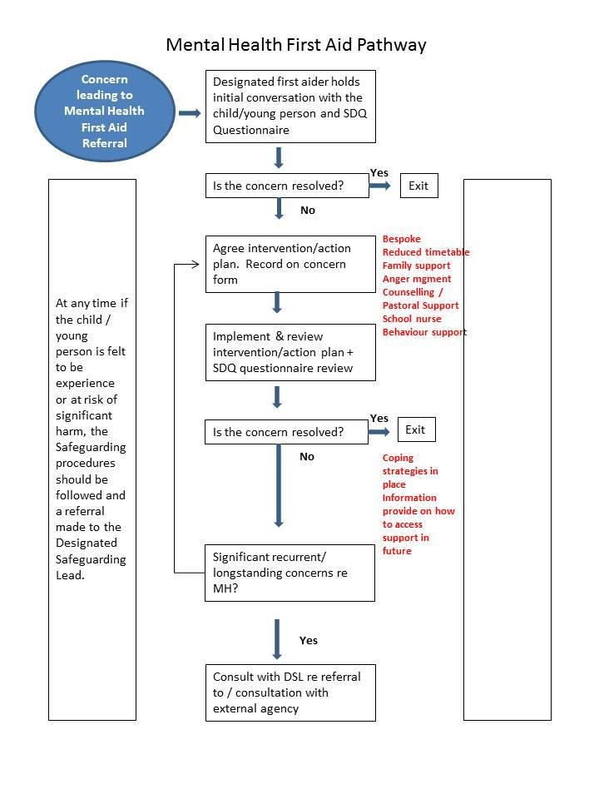

Appendix 2 – A graduated response to SEMH (*SEMH Strategy)

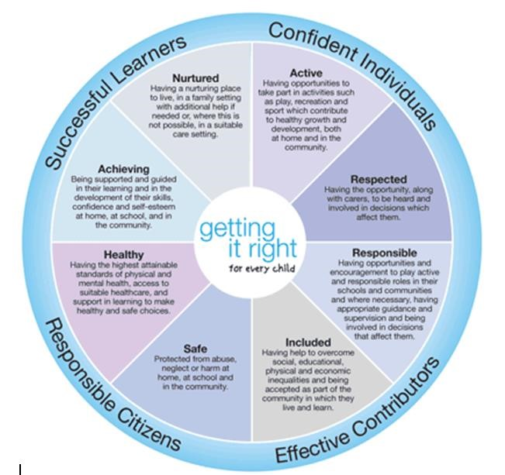

Appendix 3 - Emotional and Mental Health Needs
[[Add this section to the relevant page of your school website for advice]]
Class teachers and TAs see their students on a daily basis. They know them well and are well placed to spot changes in behaviour that might indicate a problem. Our school aims to offer support to students at such times intervening well before mental health problems develop.

Where children experience a range of emotional and behavioural problems that are outside the normal range for their age, they might be described as experiencing mental health problems or disorders. Mental health professionals have classified these as:

  - emotional disorders, for example phobias, anxiety states and depression.
  - conduct disorders, for example stealing, defiance, fire-setting, aggression, and anti-social behaviour.
  - hyperkinetic disorders, for example disturbance of activity and attention.
  - developmental disorders, for example delay in acquiring certain skills such as speech, social ability, or bladder control, primarily affecting children with autism and those with pervasive developmental disorders.
  - attachment disorders, for example children who are markedly distressed or socially impaired as a result of an extremely abnormal pattern of attachment to parents or major care givers.
  - Trauma disorders, such as post-traumatic stress disorder, as a result of traumatic experiences or persistent periods of abuse and neglect; and
  - other mental health problems including eating disorders, habit disorders, somatic disorders; and psychotic disorders such as schizophrenia and manic-depressive disorder.

Only appropriately trained mental health professionals should attempt to make a diagnosis of a mental health problem. However, the school will observe pupils daily to identify those whose behaviour suggests that they may be experiencing a mental health problem or at risk of developing one.

Certain individuals and groups are more at risk of developing mental health problems than others. These risks can relate to the child themselves, to their family, or to their community or life events. The DfE ‘Mental health and behaviour in schools 2018’ highlights the risk and protective factors that are believed to be associated with mental health outcomes in the table below:

 | Risk factors | Protective factors
In the child | - Genetic influences  - Low IQ and learning disabilities  - Specific development delay or neurodiversity  - Communication difficulties  - Difficult temperament  - Physical illness  - Academic failure  - Low self-esteem | - Secure attachment experience  - Outgoing temperament as an infant  - Good communication skills, sociability  - Being a planner and having a belief in control  - Humour  - A positive attitude  - Experiences of success and achievement  - Faith or spirituality  - Capacity to reflect
In the family | - Overt parental conflict including domestic violence  - Family breakdown (including where children are taken into care or adopted)  - Inconsistent or unclear discipline  - Hostile and rejecting relationships  - Failure to adapt to a child’s changing needs  - Physical, sexual, emotional abuse, or neglect  - Parental psychiatric illness  - Parental criminality, alcoholism, or personality disorder  - Death and loss – including loss of friendship | - At least one good parent-child relationship (or one supportive adult)  - Affection  - Clear, consistent discipline  - Support for education  - Supportive long-term relationship or the absence of severe discord

The balance between the risk and protective factors is most likely to be disrupted when difficult events happen in pupils’ lives.

These include:
  - loss or separation – resulting from death, parental separation, divorce, hospitalisation, loss of friendships (especially in adolescence), family conflict or breakdown that results in the child having to live elsewhere, being taken into care, or adopted, deployment of parents in armed forces families.
  - life changes – such as the birth of a sibling, moving house or changing schools or during transition from primary to secondary school, or secondary school to sixth form.
  - traumatic experiences such as abuse, neglect, domestic violence, bullying, violence, accidents, or injuries; and
  - other traumatic incidents such as a natural disaster or terrorist attack. Some groups could be susceptible to such incidents, even if not directly affected.

The school will provide support to pupils at such times, including those who are not presenting any obvious issues.

Identifying children with possible mental health problems

Behavioural difficulties do not necessarily mean that a child or young person has a possible mental health problem or a special education need (SEND). Consistent disruptive or withdrawn behaviours can, however, be an indication of an underlying problem. Our school is well-placed to observe students day-to-day and identify those whose behaviour suggests that they may be suffering from a mental health problem or be at risk of developing one. This may include withdrawn pupils whose needs may otherwise go unrecognised.

Self-Harm
Self-harm encompasses a wide range of issues including eating disorders, self-injury and drug/alcohol misuse. This policy focusses primarily on the cause, effect, preventative measures and supportive steps against self-injury although clearly in some cases issues may be interlinked with behavioural or other aspects covered under the broader definition of self-harm. If you are in any doubt as to your role and responsibilities (see the Safeguarding Policy).

Self-Injury
Self-injury is a coping mechanism. An individual harms their physical self to deal with emotional pain or to break feelings of numbness by arousing sensation. Self-injury is defined as any deliberate, non-suicidal behaviour that inflicts physical harm on your body and is aimed at relieving emotional distress. Physical pain is often easier to deal with than emotional pain because it causes ‘real’ feelings. Injuries can prove to an individual that their emotional pain is real and valid. Self-injurious behaviour may calm or awaken a person. Self-injury only provides temporary relief; it does not deal with the underlying ussies. Self-injury can become a natural response to the stresses of day-to-day life and can escalate in frequency and severity.

Self-injury can include but is not limited to, cutting, burning, banging, and bruising, non-suicidal overdosing and even deliberate bone breaking. Self-injury is often habitual, chronic, and repetitive self-injury tends to affect people for months and years. People who self-injure usually make a great effort to hide their injuries and scars and are often uncomfortable about discussing their emotional inner or physical outer pain. It can be difficult for young people to seek help from the NHS or from those in positions of authority, perhaps due to the stigma associated with seeking help for mental health issues. Self-injury is usually private and personal, and it is often hidden from family and friends. People who do show their scars may do so as a reaction to the incredible secrecy, and one should not assume that they are ‘inflicting’ their scars on others to seek attention, although attention may well be needed. Risk factors include, but are not limited to:

- Low self-esteem.
- Perfectionism.
- Mental health issues such as depression and anxiety
- The onset of a more complicated mental illness such as schizophrenia, bi-polar disorder or a personality disorder.
- Problems at home or school.
- Physical, emotional, or sexual abuse.

It is important to recognise that none of these risk factors may appear to be present. Sometimes it is the outwardly happy, high-achieving person with a stable background who is suffering internally and hurting themselves in order to cope. As noted above, there may be no warning signs, but some of the things below might indicate that a student is suffering internally which may lead to self-injury.

- Drug and / or alcohol misuse or risk-taking behaviour.
- Negativity and lack of self-esteem.
- Out of character behaviour.
- Bullying other pupils.
- A sudden change in friends or withdrawn from a group.
- Physical signs that self-injury may be occurring.
- Obvious cuts, scratches or burns that do not appear of an accidental nature.
- Frequent ‘accidents’ that cause physical injury.
- Regularly bandaged arms and/or writs.
- Reluctance to take part in physical exercise or other activities that require a change of clothes.
- Wearing long sleeves and trousers even during hot weather.

What self-injury is not?
Like any behaviour, self-injury may be used to attract attention, but this is not usually the focus of chronic, repetitive self-injury. If self-injury is being used in order to gain attention, one must look to find the reasons as to why someone is in such dire need of attention. It could be there is a problem at home, or issues of bullying, and they feel that no-one is listening or hearing them. Self-injury is not about seeking attention, a way of fitting in or a response to music, films or the emo or gothic culture. Prejudices and perceptions may lead people to believe they ‘know’ that self-injury is linked to a certain demographic or background, but each person is unique and will have found self-injury by their own route and rely on it at times of stress due to the release and relief it offers them.

Suicide
Although self-injury is non-suicidal behaviour and relied on as an attempt to cope and manage, it must be recognised that the emotional distress that leads to self-injury can also lead to suicidal thoughts and actions. It is therefore of the utmost importance that any concerns or particular incidents of self-injury are taken seriously and reported in accordance with the Safeguarding Policy to allow for the underlying issues to be thoroughly investigated and the necessary emotional support given, in order to minimise any greater risk. Any mention of suicidal intent should be reported immediately.

